SECTION 2 ASSIGNMENT

1.Create a Pod using nginx:latest image and run it on port 80

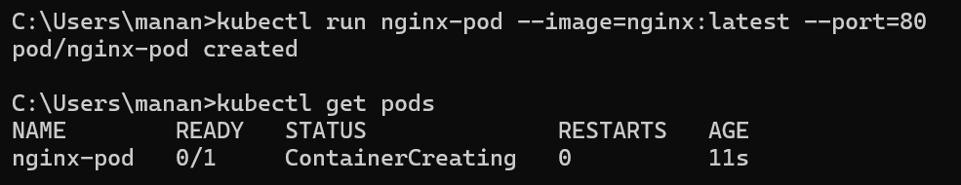

2. Create a Service and attach it to the pod and access it from the browser



3.List down the Pod in CLI

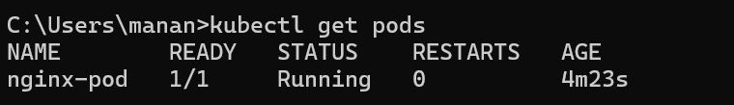

4. List down the Service in CLI



5. Check in which nodes the pods are placed

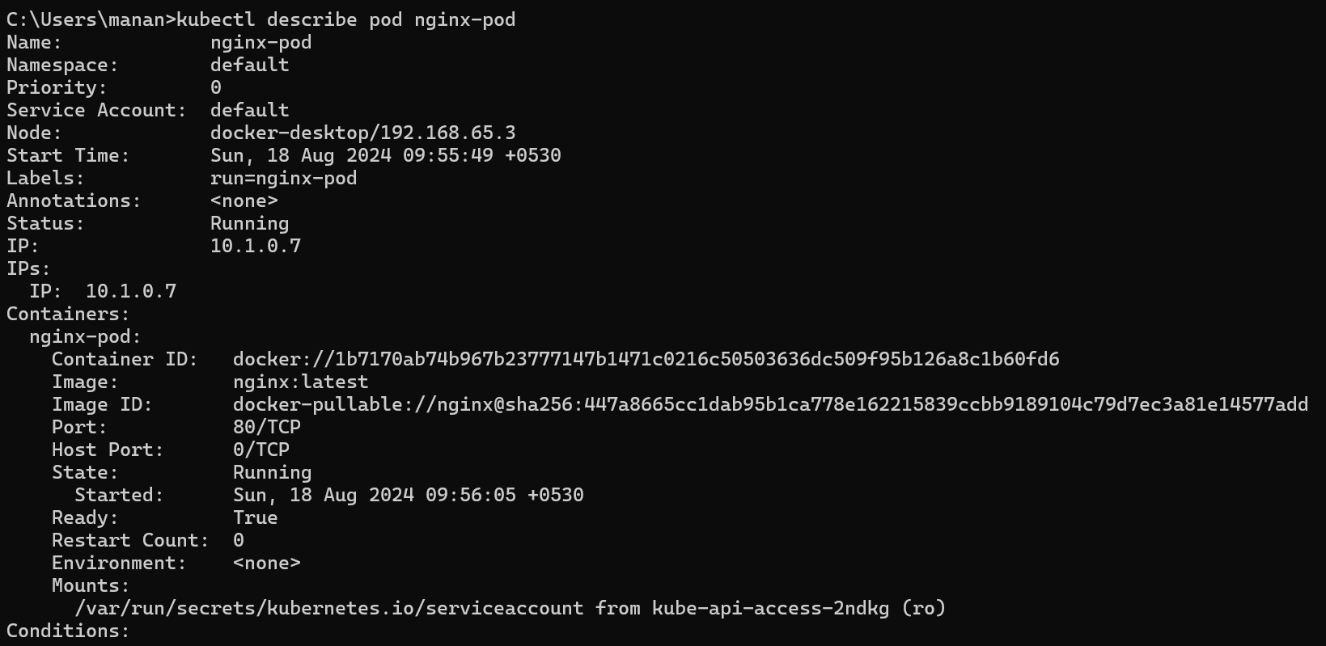

6. Describe the Pod and understand the events produced



7. Describe the Service and check the endpoints IP and observer the Pod IP

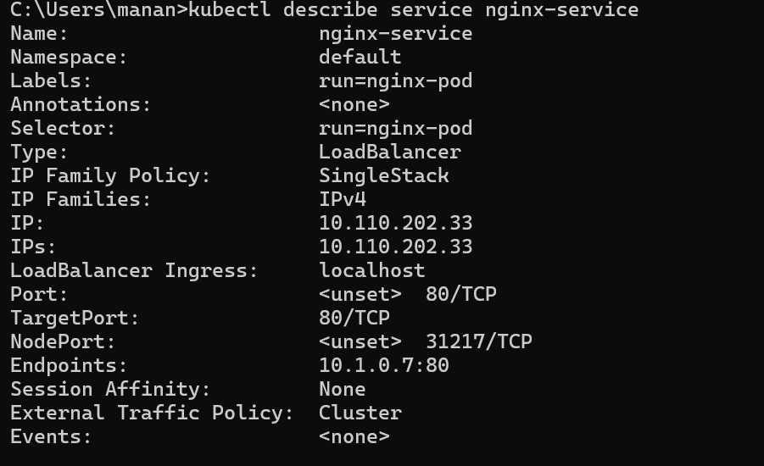

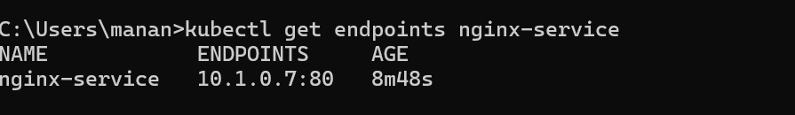

8. Delete the service

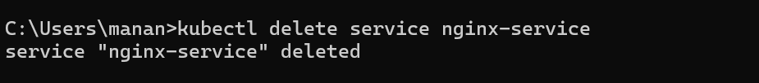

9. Create a Pod using redis1234 image and check if the pod is running or not

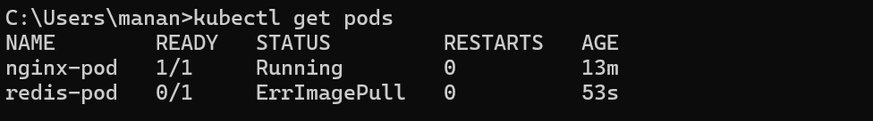

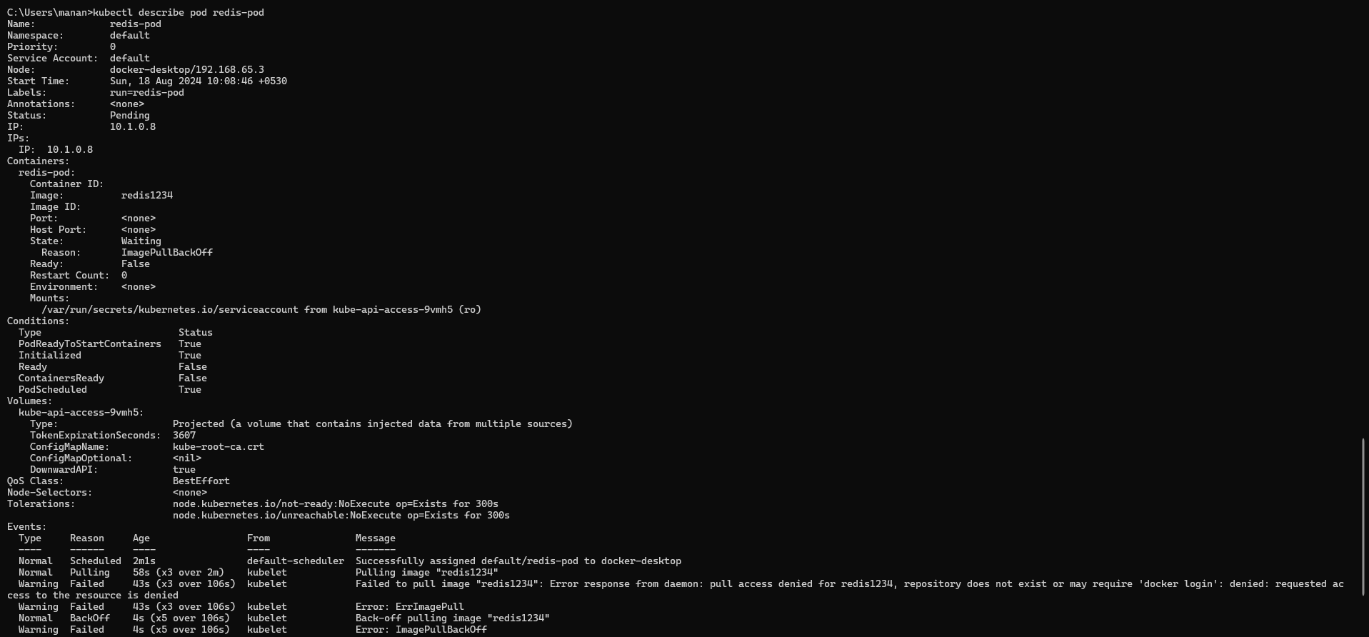

10.Delete the Pods

